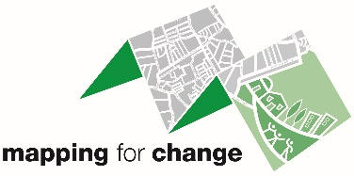
Community Engagement Officer
Hours: Part time (16 hours per week/ negotiable/ flexitime)
Salary: £26,000-£28,000 pro-rata depending on experience
Contract: Initially one year, with the potential to extend.

Mapping for Change is a social enterprise which provides participatory mapping, citizen science and stakeholder engagement services for all types of projects and entities. Our emphasis is on helping to increase participation in community life and supporting the integration of individuals from different groups and backgrounds as well as producing guidance and training to allow others to carry out such work.

THE ROLE
This varied role provides an exciting opportunity for a person with experience of community engagement to develop and progress the work of Mapping for Change in a range of different communities. The postholder will be involved in projects delivered on a local scale and across multiple European counties. Current work programmes include co-designing citizen science projects with primary schools and engaging communities to transition to carbon neutral cities. The work will involve developing and delivering workshops with various stakeholders; organising and facilitating meetings; and pro-actively recruiting participants to ensure inclusivity throughout all the engagement.

Working closely with the Managing Director, the Community Engagement Officer will play a key role in developing and delivering on-going and new projects, engaging with stakeholders from a variety of representative parties, including policy makers, NGOs and community groups. There will be opportunities to shape the community engagement programme, while benefiting from being part of the small but dynamic team.

The nature of the work undertaken by Mapping for Change is varied and may include some national and international travel. Occasional evenings and weekends will be required as dictated by the schedule of external group meetings and stakeholder availability, for which time in lieu will be given.

BENEFITS
Flexible working hours and hybrid working options offered
Office within a friendly modern Community Space in Dalston
Pension contributions matched at 3%
Potential for personal and professional development within a small and supportive team

To apply, please email info@mappingforchange.org.uk with a CV, covering letter and details of two referees.
Closing date for applications is 30th January 2023
Interviews will be held on 9th February 2023

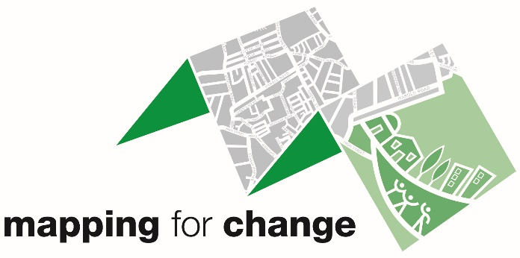
Community Engagement Officer

MAIN DUTIES AND RESPONSIBILITIES
- Organising and delivering events such as talks, workshops and roundtable discussions with stakeholders
- Developing high quality and accessible educational resources tailored to specific target groups
- Engaging and establishing relationships with key stakeholders including policy makers, NGOs and community groups
- Building a network of well informed and engaged community groups and providing on-going support and advice to those groups
- Working with communities through the modes of participatory mapping, co-design, and citizen science to collect, analyse and represent information that is important to them in representations that express their concerns
- Updating the Company website and social media with news about our work and progress of projects
- Tracking media exposure of Mapping for Change and their collaborators
- Writing updates and deliverable reports to funders and commissioners
- Adhering to Company policies and procedures, including GDPR and equality policies

PERSON SPECIFICATION
SKILLS - Essential
- Excellent written and oral communication skills including the ability to give confident and persuasive public presentations to a range of audiences
- Ability to design and deliver meetings and workshops to achieve specific outcomes
- Ability to adapt scientific and technical information to the needs of audiences
- Confident and effective in building relationships with different stakeholders, and maintaining a strong network of contacts
- Excellent planning and organisational skills with the ability to effectively time manage complex projects
- The ability to work unsupervised, providing timely evaluation and reports on activities carried out
- Ability to organise oneself, and possibly volunteers, in order to meet stringent delivery deadlines
- Good technical skills and proficient in all Microsoft packages
- A positive and energetic attitude
- A willingness to work evenings and weekends as required
- Ability to travel outside of the UK (predominantly within the EU)
- An enhanced DBS check will be required

SKILLS - Desirable
- Ability to learn about computer mapping (GIS) and use of online and offline mapping platform
- Familiarity with handling budgets

KNOWLEDGE - Essential
- Experience of organising and facilitating meetings and workshops
- Experience of community engagement in public facing roles
- Experience of working with children and young people
- Experience developing and implementing innovative engagement methodologies which are tailored to the audience
- Experience of developing promotional material in both print and web content
- Sensitivity to the cultural requirements of different communities
- Fluency in spoken and written English
- Experience of monitoring project schedules and preparing progress reports
- Demonstrable ability to learn quickly and put this into action
- Experience of working and communicating effectively with multi-disciplinary teams and within a project environment

KNOWLEDGE - Desirable
- A knowledge of the aims and objectives of Social Enterprises
- Experience of fundraising and grant applications
- Experience using social media for public engagement
- Exposure to mapping tools such as GIS and a basic understanding of visualisation of maps
- Experience in managing online platforms (e.g. a website that goes beyond a collection of a few pages)

For an informal discussion about the role, please contact Louise Francis:
l.francis@mappingforchange.org.uk or on 020 7241 6625

